**Instructions for WPSCAN**

Harrison Rockwell-Jones

**Contents**

Manual Scanning 2

1: Manual Scan Button 2

2: Selection Switch 3

3: Website Selector 3

Domains 4

1: Adding Domains 4

2: Table View Changer 5

3: Table View 5

Scan Logs 6

Options Page 6

1: Scanning Options 7

2: Automate Scanning 7

3: Date Selector 8

This application is designed for automatically utilizing the WPSCAN API to analyze selected WordPress websites and produce email reports detailing any vulnerabilities from outdated plugins and where to find their latest version.

It has these features:

* Manual scanning of an input website
* Automation of scanning lists of websites
* Add or remove certain websites from scanning list

## Manual Scanning

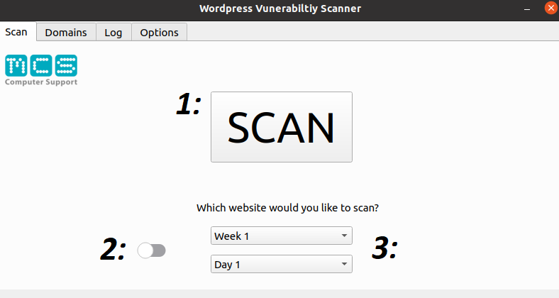

### 1: Manual Scan Button

When this button is pressed, it will attempt to scan the website(s) that have been selected using the **“3: Website Selector”**.

Once pressed, the button will become inactive and unclickable until the scan has completed or ran into an error.

After the scan has been completed it will notify the user with the text **“Done!”** and the user will be able to view the logs of the scan in the **“Log”** page.

### 2: Selection Switch

The selection switch will change how you input the website to be manually scanned using “1: Manual Scan Website”.

Once the textbox has appeared, you can manually input a website for a one-time scan.

### 3: Website Selector

The website selector selects websites from the “Domains” page that you have saved and will scan multiple websites if they are in the same column.

**Scan Page**

**Domains Page**

In this example. If you have selected Week 1 + Day 1, it will scan ***https://www.test.com*** AND ***https://www.test2.com*** as they are in the same column.

## Domains

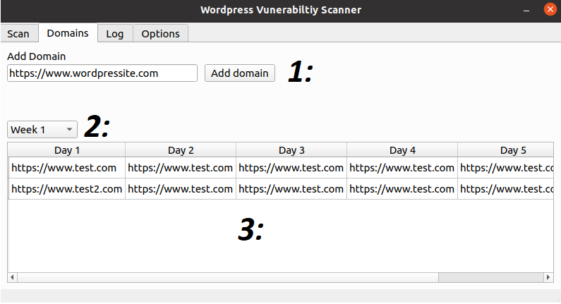

### 1: Adding Domains

Here you can iteratively add websites to the saved list. This list is used for **“Manual Scanning 3: Website Selector”****.**

If you mange to fill all 20 slots, It will add a new row and continue to add as per usual.

### 2: Table View Changer

You can select a different week to view in the saved list of websites using this drop down.

This can be used to in conjunction with **“Manual Scanning 3: Website Selector”**to understand what website is going to be scanned.

### 3: Table View

Here you can see what websites have been saved through manual editing of each cell or **“1: Adding Domains”****.**

If you want to manually edit a cell, you only need to **DOUBLE-CLICK** on the desired cell to enable editing. Once you have finished editing, click off the cell or hit **ENTER** to save your changes.

## Scan Logs

This tab shows what WPScan is doing while it’s analyzing the websites. Nothing fancy.

## Options Page

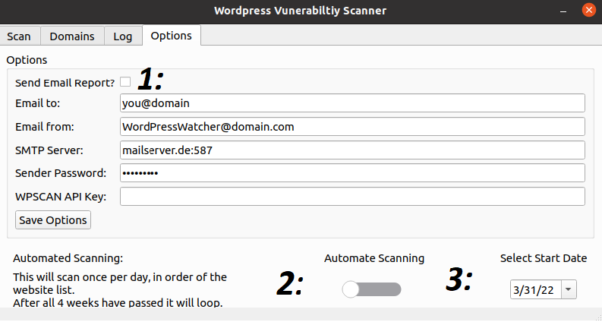

### 1: Scanning Options

Here you can configure and input details that enable scanning and the sending of email reports of said scans.

* *Send Email Report?*
  + If unticked (By default), no reports will be sent regardless of stored details
* *Email to:*
  + This is where the reports will be sent to after the scans
* *Email from:* 
  + This is where the reports are being sent from
    - E.g **reports@mcs.support**
* *SMTP Server:*
  + Input the SMTP server that the “Email From” address is using
    - E.g **smtp.office365.com**
* *Sender Password:*
  + This is where the password for the “Email From” address is input
* ***WPSCAN API Key:***
  + This is where the API key from [WPSCAN](https://wpscan.com/wordpress-security-scanner) is input to allow for successful scanning
* *Save options*
  + Saves options to the config file

### 2: Automate Scanning

Once you enable the slider, the program will start scanning on a specific schedule. This schedule is determined by **“3: Date Selector”.**

In order: (Example starting date **01/04/2022**)

* Week 1 ***(01/04/2022 – 05/04/2022)***
  + Day 1 ***(01/04/22)***
  + Day 2
  + Day 3
  + Day 4
  + Day 5 (***05/04/22)***
* Week 2 (***08/04/22 – 12/04/2022)***
  + Day 1 (***08/04/22)***
  + Etc...
  + Day 5 (***12/04/22)***
* Week 4
  + Day 1
  + Etc...
  + Day 5

Then it will loop back to week 1 and continue the cycle until disabled. Once disabled and then re-enabled it will start from Week 1 Day 1.

### 3: Date Selector

The date selector decides at what date the automation process begins.

If the selected date is the same as the current date, it will automatically scan **“Week 1: Day 1”** upon the activation of **“2: Automate Scanning”****.**

